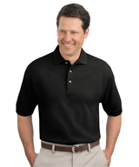
02EH 100% Cotton Piqué Polo
$13.35

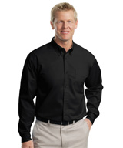
03PG Men's Long Sleeve Poplin Shirt with Pocket
$14.70

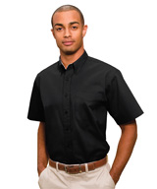
04PG Men's Short Sleeve Poplin Shirt with Pocket
$14.85
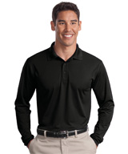
08AP Micropiqué Long Sleeve Sport-Tek® Polo
$19.75

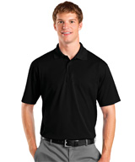
04MM Men's Micropiqué Sport-Tek ® Polos
$12.15

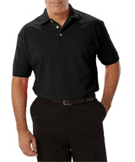
04GE Short Sleeve Polo Shirt
$11.45

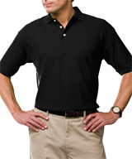
04MN New XFINITY Moisture Management Polo
$14.40

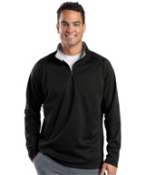
08BK 1/4 Zip Sport-Tek Sweatshirts
$22.50
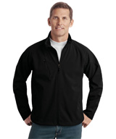
15EJ Men's Textured Soft Shell Jacket
$39.50

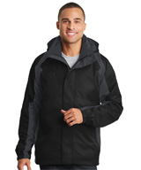
15SD 3-in-1 Parka with hood
$90.55

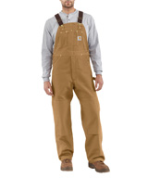
3050 Carhartt Duck Bib Overall / Unlined
$50.10
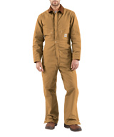
30AU Carhartt Duck Overall / Quilt Lined
$94.15

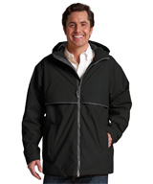
15FC Rain Jacket
$33.80

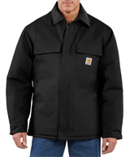
1892 Traditional Carhartt Chore Coat
$84.70
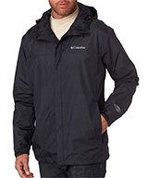
15GL Columbia Men's Watertight™ II Jacket
$64.40

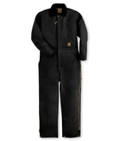
3045 Berne® Deluxe Insulated Coveralls
$55.60

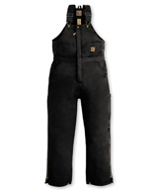
3528 Berne® Deluxe Insulated Bib Overalls
$45.55
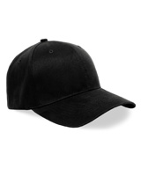
90BX Universal Fit Cap
$4.90

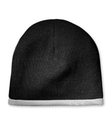
90SQ Sport-Tek® Performance Knit Cap
$5.80

