Backing Up in a Motor Vehicle (or Heavy Equipment) Safety Talk
Operating heavy equipment or a motor vehicle is inherently a hazardous task; however, backing up creates more risk for incidents to occur. According to the National Safety Council, backing accidents cause 500 deaths and 15,000 injuries per year. All too often, unnecessary backing is responsible for injuries or property damage incidents. It is important to consider the hazards of backing and what can be done to mitigate these hazards.

Hazards of Backing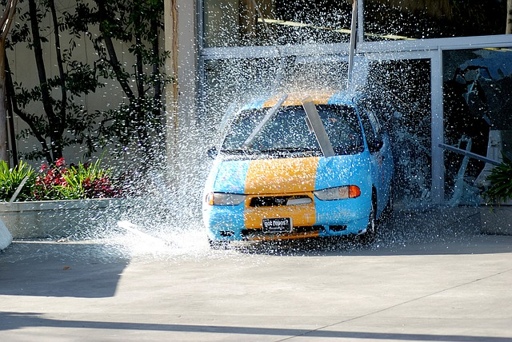
With increased blind spots, backing leaves drivers and operators at more risk for error resulting in damage or injury. The most serious incident occurring due to backing is fatalities of ground personnel. OSHA states that dump trucks, followed by semi-trucks and ordinary pickups, are responsible for the majority of backover incidents in the past ten years on the job. Outside of struck-by incidents involving ground personnel, there are many other hazards to consider. A few hazards include:
- Less visibility/ more blind spots
- Fixed objects
- Moving equipment or vehicles
- Uneven terrain (construction sites)

Best Practices and Safeguards to Mitigate the Hazards of Backing
- The single best way to prevent backing-related incidents is to eliminate backing as much as possible. Most work areas and tasks can be set up in such a way that backing up is not necessary. Preplanning of movements is another way to eliminate unnecessary backing.
- Look for pull-through parking before choosing to park where your first move is backing up. Always try to position yourself so that you can easily pull forward out of a parking spot.
- If you need to back up after being in a fixed position, complete a walk-around of your vehicle. This allows you to be aware of what is in your blind spots prior to making a move.
- Install backup cameras on equipment and vehicles.
- Use a spotter when appropriate. If backing is necessary and there are hazards, such as other ground personnel or fixed objects in the area, then a spotter may be necessary. Always consider the additional hazards created when a spotter is used in a work area with moving equipment or vehicles.
- Mark fixed objects, so they are more visible to those operating a motor vehicle or heavy equipment in a work area.
- Place protective barricades to protect critical or expensive equipment from struck-by incidents.

Summary
Backing can almost always be eliminated or greatly reduced when proper preplanning is used. Elimination should always be the first choice before relying on less effective safeguards such as backup cameras or a spotter.
Discussion point: Are we doing a lot of unnecessary backing during our work tasks?

