Bees and Wasps

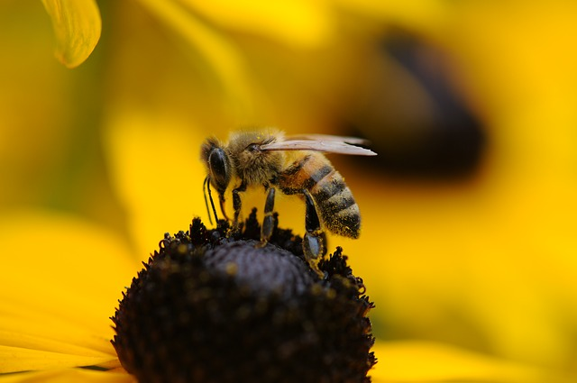Bees and Wasps Safety Talk
Almost everyone has experienced some type of bee or wasp sting in their life. Stings from these insects do not pose a major issue for most people. However, for others, there can be a severe allergic reaction that is life-threatening. Even if you have not experienced a severe allergic reaction to stings before, it is possible to have a severe reaction at any point in your life. It is important to avoid bees and wasps as well as being able to recognize when someone is suffering from a severe allergic reaction from an insect sting.

Bee and Insect Sting Facts
According to NIOSH, thousands of people are stung by insects each year, and as many as 90–100 people in the United States die as a result of allergic reactions. This number may be underreported as deaths may be mistakenly diagnosed as heart attacks or sunstrokes or may be attributed to other causes. Most individuals only experience minor swelling and pain after being stung, but many individuals can experience other symptoms after a sting. Insect stings can result in any of the following symptoms:
- Pain
- Redness
- Swelling (in area of sting and sometimes beyond)
- Flushing
- Hives
- Itching
- Anaphylaxis

Secondary Dangers of Bees and Wasps
Outside of getting stung, there are other problems these insects can cause. Many people panic if there are any bees around them. This causes incidents to occur. For example, a bee enters a window of a vehicle. The driver does not pay attention to the road, crosses the centerline, and runs head-on into another vehicle. Another example is an individual working at heights on a ladder. He begins to hammer on the side of a house, disturbing a bee’s nest. After the first sting, he panics which causes him to fall off the ladder.
It is important to consider secondary hazards these insects can create.

Sting Prevention
Before performing any work in an area, it is important to do a site walk to look for any hazards including bees and wasps. Often times, people start performing a task not knowing there is an active hive in close proximity to them. Avoiding areas where bees or wasps are is the most effective way to prevent stings. If you are severely allergic to bees or wasps, avoid any work that puts you at great risk of getting stung. Wear clothing that covers as much skin as possible when working in areas where there may be bees and wasps. It is harder for stinging insects to sting through clothing.

If Stung
If a person has a history of severe reactions to stings, call 911 immediately. If the person is showing signs of a severe reaction or cannot breathe, inject epinephrine into the outer muscle of the thigh if it is available. For individuals who are not severely allergic then the first step is to remove the stinger with the edge of a credit card. After the stinger is removed apply ice to the area to control any swelling. Keep the sting area clean until it is healed up.

Summary
Take the hazards that bees and wasps create seriously when working outdoors. Even if you are not allergic to them someone close by may be. Do a site check before entering an area to perform work. Avoiding areas where these insects are is your best option to prevent stings. When avoiding them completely is not an option and there is a nest in the area try to not disturb them. If contact cannot be avoided, have them removed to another location by a professional or have them killed (if that is the only option) to protect yourself and others from stings. Always have an EPI pen nearby if you or a coworker is severely allergic to insect stings.

