Easy Way Instead of the Right Way Safety Talk
There are many reasons why incidents occur that result in property loss or injury on the job. Oftentimes, there have to be multiple failures in the safeguards that are put into place (or not put into place) for an injury to occur due to an exposure to a hazard. A major reason there is a failure in the safeguards that are supposed to protect employees is that individuals take the easy way out when completing the work task instead of doing it the right way. It is necessary to recognize the importance of doing tasks the right way every time and the consequences of not doing so.

Reasons Behind Doing Tasks the Easy Way
There are many reasons or excuses an individual will point to when asked why they are not performing a work task the right way. Some of these reasons include:
- “There is not enough time to do the task the right way”
- “Management does not enforce the rules or has unrealistic expectations”
- “I have done it this way for years and nothing bad has ever happened”
- “I do not have the energy to do the task the way you want it done”
Regardless of the reason, taking the easy route when it comes to ensuring safe work practices and procedures are being followed leaves you and everyone else around you at risk.

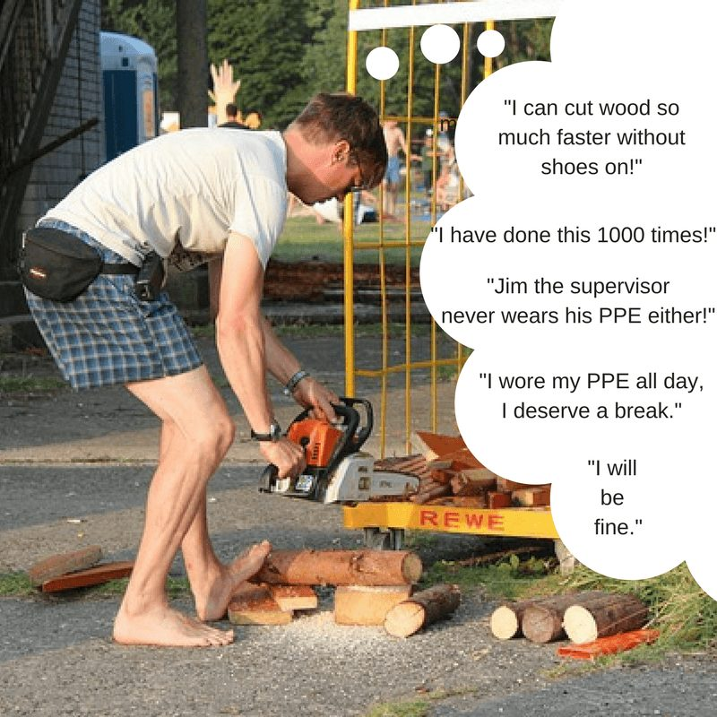Why We Should Do Tasks the Right Way Every Time
There are many reasons why we should do our best to do every single task the right way every time. The main reason we should do so is to keep both ourselves and our fellow coworkers safe from being injured on the job. Another reason why we should do every task the right way is because working safely is good business.
Keeping people healthy on the job is not only good for the individual workers, but it also helps a business thrive by avoiding unnecessary costs resulting from injuries. When the business does well, everyone benefits in some way.

Summary
It should be no surprise that a contributing factor of workplace injuries can be attributed in some way to doing one part of a task, or a whole series of parts of a larger work task, the easy way instead of the right way. This can manifest itself in a variety of ways but regardless, cutting corners will lead to exposure to more risk than necessary. Evaluate the tasks you do at work and ask yourself if you are doing them the easy way instead of the right way.
Discussion point: Give examples of taking the easy way over the right way when it comes to working safely.

