Heat Stroke Safety Talk
Heat stress creates many hazards in the workplace for those employees who have to work in a hot environment. Hot environments can create indirect safety hazards, such as causing employees to lose focus on their work task or becoming fatigued. Heat stress also causes more direct illnesses, such as heat cramps, heat exhaustion, and heat stroke. According to a report published by the CDC, during 2004–2018, an average of 702 heat-related deaths (415 with heat as the underlying cause and 287 as a contributing cause) occurred in the United States annually.

Heat Stroke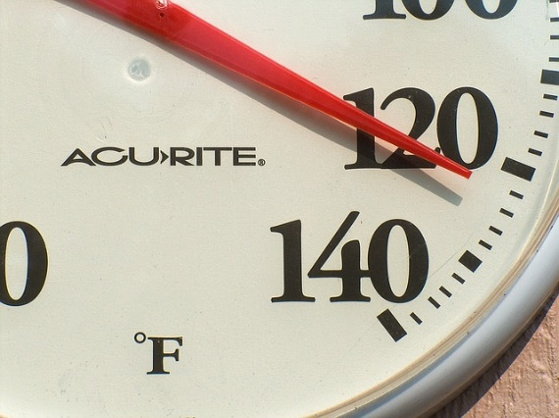
Heat stroke is the most serious heat-related illness. This illness can kill or cause damage to the brain and other internal organs. Heat stroke results from prolonged exposure to high temperatures — usually in combination with dehydration — which leads to failure of the body’s temperature control system. If someone who is exhibiting signs of heat stroke is not properly treated immediately, then there can be permanent health issues or death.

Prevention of Heat Illnesses
- Allow for acclimation to hot environments. It can take two weeks before an individual’s body is used to working in a hot environment.
- Take plenty of breaks in a cool or shaded area.
- Drink plenty of water before you are thirsty.
- Keep an eye on coworkers. Monitor each other for signs of heat illness.

Signs of Heat Stroke
(source: www.WebMD.com)
- Fainting may be the first sign
- Dizziness
- Lack of sweating
- Red, hot, and dry skin
- Rapid heartbeat or breathing
- Confusion
- Vomiting

Treatment of Heat Stroke
- Alert your supervisor and call 911 immediately
- Take worker to a shaded or cooler area if possible
- Apply cool water to their body or place them in a shower or tub of cool water
- Place ice packs in their armpit and groin areas, if available, to help lower their core temperature

Summary
It is important to prevent heat illnesses before they become an issue in the workplace. Knowing the signs, symptoms, and treatment of heat illnesses, especially heat stroke, can save someone’s life. When in doubt, always call 911 to get an individual the proper treatment they need.

