The Importance of Water Safety Talk
Water is one of the most important substances on Earth. All plants, animals, and people need water to survive. Water serves very important purposes to our bodies and our bodily functions- some of which you may not even be aware of.

Interesting Facts Regarding Water’s Role for Our Bodies
- Water comprises more than 60% of our body weight.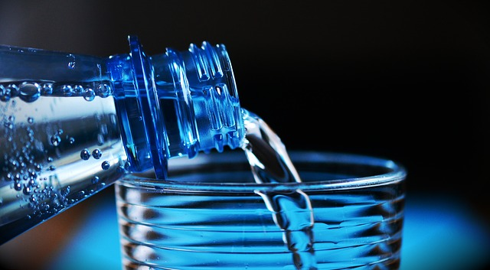
- Lack of water is the #1 trigger for daytime fatigue.
- A 2% drop in water level of the body can spur problems with short-term memory.
- Water naturally cleanses the body of toxins.
- Water regulates the body’s cooling system.
- Water acts as a lubricant and cushion to our joints.

Hydration Tips
- It is recommended to drink at least 50oz to 64oz of water a day, depending on what source you refer to. That is about three to four regular-sized water bottles a day. This amount is a minimum amount to shoot for; you may need even more water than that. Many people do not realize how little water they actually drink. Pay attention to how much you drink today and add to it if needed.
- Do not wait until you are thirsty to drink water. By the time the body tells you that you are thirsty, dehydration is already occurring.
- Other beverages, such as soda or coffee, steal water from your body and make you more dehydrated. Limit these types of drinks throughout the day.
- Your urine can serve as an indicator of whether you are hydrated or not. If your urine is clear or pale and you are using the restroom regularly, you are probably hydrated. If your urine is dark and you are visiting the restroom less frequently, you need to drink more water. While you should not solely rely on this indicator, it can be helpful in gauging whether or not you need to drink more water.

Discussion point:
-How many people think they drink at least 3 to 4 water bottles worth of water a day?

