Lightning Safety Talk
Lightning is a serious hazard both on and off the job. There is an average of 25 million lightning strikes that occur in the United States each year alone. Individuals need to identify and plan for the potential of lightning before beginning a work activity or any leisure activity during storm season. Have a plan of when you will cease work and where you will go if lightning occurs during that day. The best practice to avoid getting struck by lightning is to take shelter indoors before a storm is in your immediate area.

Lightning Fatality Statistics
- From 2006 to 2019, 418 people were struck and killed by lightning in the United States. (weather.gov)
- Males accounted for 79% of these fatalities.
- Off-the-job activities that resulted in the most fatalities include fishing, beach activities, camping, boating, soccer, and golf.
- Most deaths occurred in the months of June, July, and August
- Many victims were headed to safety at the time of the fatal strike.

Five Lightning Myths
1. If there are no clouds or rain, there will not be lightning. TRUTH: Lightning can strike 3 miles from the actual storm center. There are some bolts that have struck 10 miles or more from the storm.
2. Lightning does not strike the same place twice. TRUTH: Lightning often strikes the same place multiple times. Examples include tall metal buildings, cell phone towers, and tall trees in fields.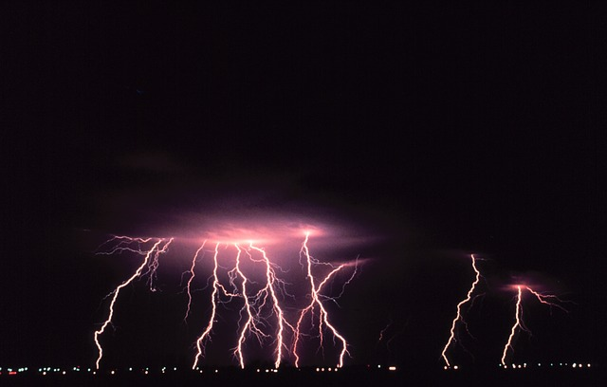
3. Rubber tires on a car protect you from lightning by insulating you from the ground. TRUTH: It is not the rubber tires that protect during a lightning strike. The metal frame of the car protects you from the electricity passing through the vehicle into the ground. The metal acts like a faraday cage around you.
4. Take shelter under a tree during a thunderstorm. TRUTH: As mentioned above, trees are often hit by lightning. Many lightning-related injuries involve a person who was under or near a tree during a lightning strike.
5. If you are in a house, you are 100% safe from lightning. TRUTH: A house is a safe place to be during a thunderstorm as long as you avoid anything that conducts electricity. This means staying off corded phones, electrical appliances, wires, TV cables, computers, plumbing, metal doors, and windows.

Summary
It is important not to be complacent when it comes to lightning. While the total number of fatalities each year is relatively low, the severity of lightning strikes is significant. Weather.gov reported that only 10% of those who are struck by lightning are killed. The other 90% of victims are left with various degrees of disability.

Discussion points:
- What are some other lightning safety tips or myths?
- What is our policy for lightning here at work?

