Muddy Work Areas Safety Talk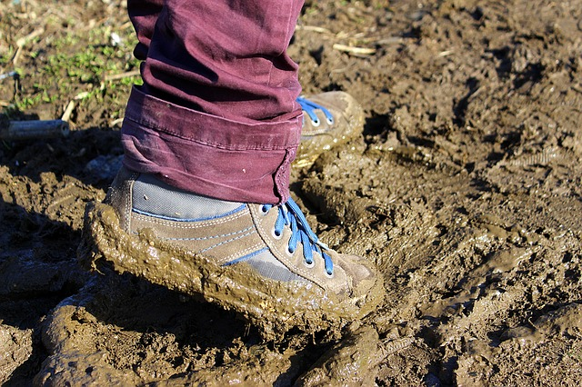
Weather can create many hazards and slow down production for construction sites and other work sites that are outdoors. This is especially true when rain creates excessively muddy conditions. There are many different hazards to consider if work is going to take place in muddy conditions.

Hazards and Injuries Created by Muddy Work Areas
- Equipment/ vehicle crashes or over-turn. Traction and control are greatly reduced when operating on mud.
- Slips, trips, and falls. Walking around or getting into equipment in the mud can lead to slipping or falling.
- Sprains/ strains. Many people will pull muscles due to getting their boots stuck in the mud and trying to yank them out. Also, falling over with your feet stuck in an awkward position can lead to suffering a sprain or strain injury.

Best Practices When Working in Mud
- The single best practice is eliminating work in excessively muddy areas until it clears up or work areas are addressed.
- Dress up areas with equipment such as a bulldozer to get down to more solid ground.
- If work is continuing in an area that is muddy, stop when needed to dress it up again. It takes less time to fix an area to make it safer than it does to pull out stuck vehicles or equipment that tips over.
- Never drive into excessively muddy areas or down slick slopes. Getting stuck creates more hazards due to other personnel having to come into the field to pull out your vehicle or equipment.
- If you get your foot stuck in the mud, slowly work it out by moving your foot back and forth. Yanking on it is not very effective and can result in injury.
- Maintain clean steps on equipment and remove mud off of your boots before climbing up and down equipment. Always use three points of contact.

Summary
While these safeguards seem like common sense, many injuries and property damage incidents occur every year due to poor site conditions. Use your best judgment when working in the mud. Do not put yourself in a situation where you make a bad situation worse. Always adjust work plans to site conditions.

Discussion point:
-What other hazards or considerations do we need to take into account when dealing with muddy site conditions?

