Road Rage Safety Talk
The roads can be an extremely dangerous place. According to the National Safety Council, an estimated 42,000 people died in motor vehicle crashes in 2020. Year after year, motor vehicle accidents are at the top of the list for causes of workplace fatalities. The risk of motor vehicle accidents can be drastically reduced when individuals do not partake in unsafe driving behaviors.

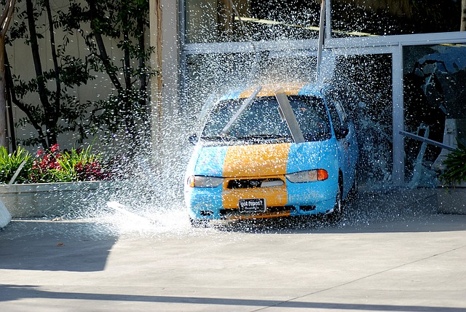Contributing Factors to Motor Vehicle Accidents
There can be a multitude of factors that contribute to a motor vehicle accident. One single unsafe act or unsafe condition can be enough to cause an accident. Often times there are multiple unsafe acts and conditions that lead to a motor vehicle accident. One common unsafe act is taking part in “road rage” activities.

What is Road Rage?
Everyone has heard the term road rage, and most people have probably experienced some degree of it while driving. The National Highway Traffic Safety Administration defines road rage as when a driver “commits moving traffic offenses so as to endanger other persons or property; an assault with a motor vehicle or other dangerous weapon by the operator or passenger of one motor vehicle on the operator or passengers of another motor vehicle.”
Road rage is defined differently from aggressive driving by making the point that road rage involves using a vehicle in a way that endangers other individuals on purpose.

Some Statistics on Road Rage Prevalence and Incidents
There is limited research and reliable statistics on road rage due to the nature of what it is. One organization that has looked into road rage data is the AAA Foundation. Below is some of what information that has been published by the organization regarding aggressive driving and road rage.
- They found that between 1990 and 1996 road rage contributed to 218 deaths and 12,610 injuries.
- They found that from 2003 to 2007, over half of fatal crashes involved at least one driver who performed a potentially aggressive action.
- A recent study (of U.S. drivers) found that nearly 80 percent of drivers expressed significant anger, aggression or road rage behind the wheel at least once in the previous year.
- Some of the most common aggressive driving behaviors exhibited by U.S. drivers within the last year were purposefully tailgating at 51 percent of all drivers (104 million drivers), yelling at another driver- 47 percent (95 million drivers), honking to show annoyance or anger- 45 percent (91 million drivers).

Preventing Road Rage and Dealing with Confrontation
The AAA Foundation provides the following guidance for preventing road rage incidents:
- Maintain adequate following distance.
- Use turn signals.
- Allow others to merge.
- Use your high beams responsibly.
- Tap your horn if you must (but no long blasts with accompanying hand gestures).
- Be considerate in parking lots. Park in one spot, not across multiple spaces. Be careful not to hit cars next to you with your door.
If you find yourself dealing with an angry or aggressive driver try the following:
- Avoid eye contact with angry drivers.
- Don’t respond with aggression towards the angry driver.
- If you feel you are at risk, drive to a public place.
- Use your horn to attract attention but remain in your locked vehicle.
- If you are confronted, stay as calm and courteous as possible.
- If you feel threatened, call 911.

Summary
Do not take part in road rage or aggressive driving. Do not let the actions of others on the road dictate your emotions. There are no winners when it comes to road rage. If another driver is angry with you follow the advice provided to avoid escalating the situation any further and to remain safe.
Discussion point: Has anyone ever experienced road rage leading to an accident or physical confrontation?

