Trip Injuries and Prevention Safety Talk
There are many times when the hazards with the most severe outcomes are focused on more than the common hazards found in a workplace. A good example of a common hazard that can be overlooked are trip hazards. It is important to give attention to trip hazards in your work area to prevent yourself from being injured or a coworker.

Trip Injuries in the Workplace
Trips are lumped into the same category as slips and falls in most injury statistic data. While it is difficult to separate trip injury data from the other two, the overall data for this category of injuries is staggering. According to the 2017 edition of “Injury Facts,” a National Safety Council chartbook, injuries from slips, trips, and falls resulted in 247,120 cases involving days away from work, and 818 worker deaths in 2014. While falls are undoubtedly responsible for the majority of fatalities, trips cause far too many injuries in the workplace.

Common Trip Hazards Found in Workplaces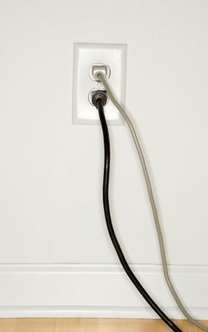
There is an endless list of possible trip hazards found in a workplace. Some common examples to look for in your work area today:
- Extension cords
- Tools, equipment, materials
- Debris
- Cracks in floor
- Spaces or holes in flooring
- Changes in elevation
- Unexpected sloping
- Loose carpet or rugs
Certain environmental factors in a workplace can also increase the chance of a trip occurring when paired with the above hazards.

Common Environmental Factors that Increase Risk of Trip Incidents
- Glare
- Poor lighting
- Shadows
- Excessive dust
- Noise
- Temperature extremes
- Distractive work environment

Best Practices to Eliminate Trip Incidents from Occurring
Eliminating trip hazards is relevantly simple compared to some workplace hazards. Here are a few ways to lessen the chance someone is injured at your workplace due to a trip incident.
- Eliminate as many trip hazards through proper housekeeping and work area setup. Poor housekeeping leads to the majority of trip hazards in most workplaces.
- Paint or mark changes in elevation with bright paint or signage to alert others of the danger.
- Have any open holes, cracks, spaces, etc., on walking surfaces repaired as soon as possible.
- Completely block off areas that have excessive trip hazards until fixed or addressed.
- Tape down cords to the floor or hang them up out of the way, so individuals walking through the area do not trip on them.

Summary
Do not let complacency creep in when dealing with addressing trip hazards. Do not underestimate how far simple measures such as good housekeeping practices can go in preventing injuries. Evaluate your work area today for the hazards and environmental conditions mentioned in this safety talk.
Discussion point: What are other common examples of trip hazards in this workplace?

