10 Shelving Safety Tips to Keep your Warehouse OSHA Approved
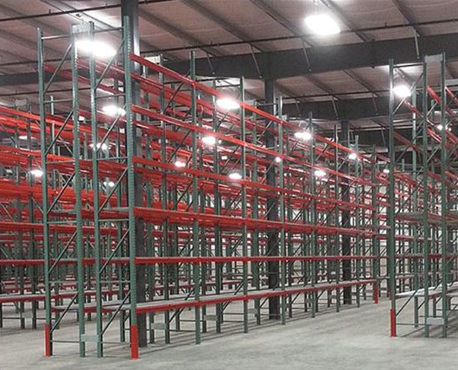
For warehouse owners, safety isn’t just a matter of looking good to potential clients. The costs associated with a warehouse pallet rack accident can be incredibly high, and while various forms of insurance can cover some of the costs, some will be the employer’s burden to bear.
Accidents can also result in a visit from the Occupational Safety and Health Administration (OSHA), which can result in heavy fines and follow-up visits. Even if the accident wasn’t management’s fault, the paperwork and resulting lost time can be burdensome.
Since you can’t always control your employees’ actions, the best way to prevent accidents is to make your infrastructure as safe as possible. However, training of employees is still critical, as there is no way to make a warehouse or factory completely free of hazards. In addition to following best practices and general shelving guidelines from OSHA, take care to proactively protect shelving from damage and monitor any slight damage or leaning that occurs over time.

1. Secure Tall Shelves
The OSHA standard for maximum freestanding shelf height is 15 feet, but other than that, OSHA standards can be a little vague about specifics for shelving safety. If an accident occurs, though, employers can be cited under OSHA’s General Duty Clause, which states that employers must do their due diligence to protect employees from harm.
Thus, employers can be cited for failing to secure tall shelves of any height, especially if they contain heavy objects. Shelves should be bolted to each other, to the floor, and a wall if possible. Plus, shelves need to have a height-to-depth ratio of 6:1 or lower, as securing shelving with insufficient depth becomes extremely difficult.
Even well-secured warehouse pallet racks can become hazardous if improperly loaded. Always load heavier pallets onto lower shelves, even if it means using space somewhat inefficiently. When in doubt, take the time to free up space on lower shelves by moving lighter objects to higher shelves.

2. Inspect Up-Close
Rust, missing safety clips and bolts, bending shelves, and other seemingly minor damage can have serious consequences. Even if your shelves are relatively new, take the time to inspect them once every few months. Make sure also to inspect stairs and ladders, including their wheels, as these can be damaged just through everyday use.
Also, make sure to re-inspect shelving units after every accident, no matter how minor. A forklift collision with a corner of the shelving unit can cause safety clips to become dislodged in another corner.
If possible, have a supervisor or manager do a brief walk-through inspection of shelving once per day. This will hopefully allow leadership to catch and deal with any damage from unreported forklift accidents or other mishaps. Do a more thorough inspection, with a flashlight and level in hand to inspect potential damage, every few months or after any event that could have caused damage.

3. Measure Leaning Shelves
You can usually figure out if a shelf is leaning by holding up a level to various vertical sections of it. If one or more of the sections you measure isn’t vertical, you will need to determine just how much the shelf is tilting. A shelving professional can help you make those measurements correctly.
OSHA currently considers ANSI MH16.1-2012 to be the defining set of guidelines on shelf out-of-plumb problems. Based on these strict guidelines, a shelving unit must be unloaded and re-plumbed if its out-of-plumb ratio exceeds 1:240. In other words, if a 10-foot-high rack is leaning more than half an inch, it needs to be straightened or replaced.
Ideally, have a professional measure plumbness every few months, and schedule a re-measurement sooner if a shelf starts to lean more than a quarter of an inch. If you are certain that you or another manager has the skills to measure shelf plumbness correctly, then it can be done in-house. Make sure to take detailed notes on which shelves were measure from which angles. While this can be a hassle, it’s far better than dealing with problems associated with a pallet accident.

4. Enforce Weight Limits
Putting too much weight on shelves is a sure way to set your warehouse up for a catastrophe. Even if the shelf appears to be holding the weight without visible damage, the additional strain put on the shelving and supports makes the whole structure vulnerable to sudden collapse. Plus, long-term wear and tear on key parts will occur much more quickly.
It can be hard for managers to determine at a glance how much weight is being put on shelves. Supervisors will probably need to be primarily responsible for enforcing limits, and for noticing if an unusually large amount of goods is being placed on one shelf. Make sure to establish a good relationship with supervisors, so that they feel comfortable enforcing weight guidelines and reporting any problems directly to you.
If there are ever any doubts about the weight capacity of shelving, contact the manufacturer. The capacity of shelving can be greatly reduced by rust or impact from accidents, so shelves should be unloaded completely and re-inspected after any accident. If there is any significant damage, the entire affected part and any bolts or clips that it used should be replaced.
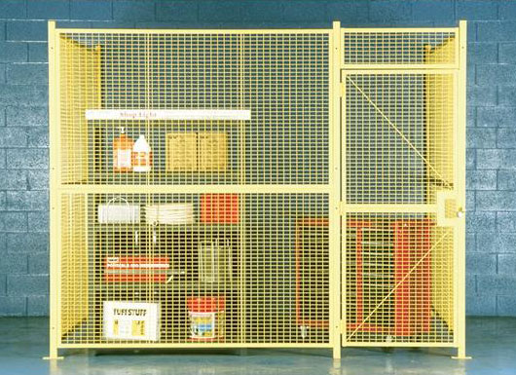

5. Use Wire Cages and Guardrails
Some goods are potentially hazardous if involved in an accident involving a forklift. Flammable and very fragile goods should be kept quarantined and shouldn’t be handled with a forklift, if at all possible. This includes aerosols, as a punctured aerosol can could cause significant damage or even breathing problems for nearby workers.
Consider using wire fencing to protect flammable and fragile goods and make the fenced-off area a forklift-free zone. You can also use flammable goods cabinets to keep flammable gas and other hazardous warehouse supplies separate from shelves that hold regular goods.
Sometimes fragile goods still need to be kept in pallet form, making them too heavy to move without a forklift. In this case, consider thoroughly protecting their storage shelves with guardrails. Even in areas that aren’t storing fragile goods, guardrails can help protect shelving and other key infrastructure from damage caused by forklift accidents. While guardrails require an initial up-front cost, they can prevent thousands of dollars in damages and lost man-hours caused by damage to shelving units.
Also, consider installing guardrails and wire fencing between pedestrian and forklift areas, and between loading docks and shelving areas. For facilities with a large number of human resources staff or visiting clients, having fencing and a gate between office areas and pallet racks can help ensure that the area should not be entered unless necessary and authorized by a manager. Loading docks are a major cause of forklift accidents, so they should be visually or physically separated from pallet racks and other shelving.

6. Make Aisles as Wide as Possible
No matter what type of facility you operate, making the most of available space is a challenge. For growing businesses, making storage space as tight as possible seems tempting, as it theoretically improves capacity and profits.
However, narrow aisles can be a significant cause of forklift accidents and can even cause problems for experienced forklift drivers. The less room there is for forklifts to maneuver, the more likely it is that a forklift will collide with shelving. Tall shelving overshadowing a narrow aisle can also increase the risk of a collision caused by poor lighting. OSHA recommends that aisles be at least 4 feet wide, or 3 feet wider than the largest equipment used, so aisles, where employees utilize forklifts, will need to be a bare minimum of 7 feet across.
Narrow aisles can even contribute to pallet jack and handcart collisions. When aisles are narrow, it makes it hard to see and avoid anyone coming from an intersecting aisle. While these types of accidents are often minor, they still need to be logged and dealt with accordingly. Plus, sprained ankles, bruises, and other injuries can still cause lost work time.

7. Train and Re-Train
OSHA mandates forklift training, and employers should never allow untrained employees to operate a forklift. However, training for other equipment, such as handcarts, should be thorough as well. Even employees who don’t regularly lift and load pallets should be trained on basic safety procedures regarding shelving areas, in case they ever need to enter the areas.
Naturally, some employees retain their training better than others. While OSHA only requires in-depth refresher training for forklift drivers if they have been involved in an accident or have been witnessed driving unsafely, all employees should undergo a refresher training on general safety procedures once a year. While this may be tiresome for veteran employees, you can come up with a fun way to review safety protocols. Consider making a game where teams are rewarded points for correctly remembering rules.
Since refresher training can take time out of the workday and impede operations if everyone has to attend at once, it’s okay to run two or even three different refresher training with different groups of employees. Just make sure that everyone who operates forklifts gets a thorough re-training specifically about forklift operation.
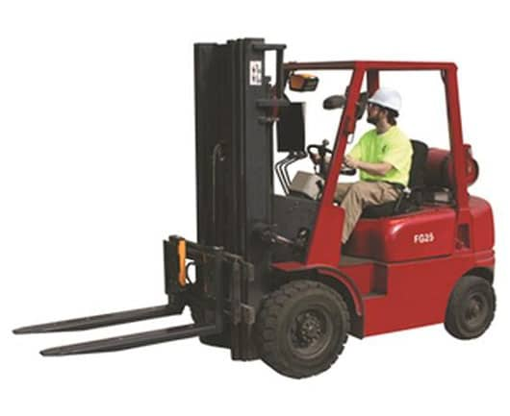

8. Maintain Appropriate Staffing Levels
Speeding and rushing through picking tasks is a sure way to cause forklift accidents. Understaffing in warehouses can contribute to accidents and end up causing a citation from OSHA. If staff are barely completing their tasks by the end of their shift, examine the situation and see if an additional worker or two can help. Resist the temptation to have human resources staff or other untrained workers fill in, as they can quickly cause an accident.
On the flip side, having too many people milling about warehouse floors can increase the chances of an accident. Consider hiring seasonal workers to deal with temporary increases in demand, instead of having extra full-time staff on hand in case of sudden increases in work. If staff sizes do need to grow rapidly, splitting workers into two or even three shifts may help keep things running smoothly.
Watch out for situations where you may need to tweak staff assignments. For example, rookie forklift operators should not be left entirely unattended through their first few days on the job. While it’s not realistic for someone to be watching over their shoulder all the time, a supervisor or even a veteran forklift driver should be assigned to keep an eye on them as they are loading and unloading racks. This supervision can be phased out over a few weeks.

9. Conduct Walkthroughs
Even the best training and staffing ratios will sometimes fail to prevent safety violations. It is management’s responsibility to monitor and correct unsafe practices, but that’s impossible to do thoroughly from inside an office. While responsible and trusted supervisors are a great asset, some issues might be overlooked unless a fresh set of eyes is brought in.
Holding unplanned walkthroughs of facilities is the best way to spot unwanted behaviors. Discreetly walk around the shelving, watching workers’ behavior, and taking note of any clutter left around shelving. Climbing pallet racks, driving forklifts too fast, and other risky behavior can often occur when workers think that they can cut corners.
Walkthroughs aren’t just good for checking on forklifts and shelving safety issues, either. They’re great for checking for damaged equipment, lighting problems, wet floors, and other hazards. This is also the best time to take note of workloads and make sure no one is running around to complete tasks on-time.

10. Get Better Infrastructure
Ultimately, the best way to reduce accidents in a warehouse is to reduce the number of potential causes. Human error is hard to eliminate, especially when forklifts are involved. While getting better lighting and installing better safety features can help significantly, there will always be minor accidents as long as forklifts are operating in a warehouse.
Installing automated picking systems may seem like a lot of work, but they actually decrease the man-hours required in the long run. They’re also more user-friendly than ever, and their software can be highly customized to suit most warehouse applications. Manufacturers of these systems provide expert help with designing, setting up, and maintaining the software and hardware needed to keep them running.
While automated systems may not work for every business, they usually work significantly better than existing warehouse pallet racking systems. For example, automated vertical lift systems can fit a large variety of warehouse sizes and storage needs while reducing the space required to store goods. Workers can summon a particular item with a touch of a button, eliminating the risk of collisions, falls, and other accidents.
The future of warehouse pallet racking doesn’t rely on error-prone systems. If you’re considering upgrading to a more efficient system, the best time to do so is now. Keeping OSHA satisfied is easy when safer systems are used to eliminate human error and risk factors.

