The Occupational Safety and Health Administration (OSHA) has evaluated ways to help prevent lifting injuries. It specifies two types of controls: engineering and administrative. Engineering controls are used to redesign the workstation to minimize lifting hazards. Administrative controls include carefully selecting and training workers so that they can perform their jobs safely.
OSHA suggested engineering controls implement physical change to the workplace, which eliminates/reduces the hazard on the job/task. Examples include:
- Use of a device to lift and reposition heavy objects to limit force exertion.
- Reducing the weight of a load to limit force exertion.
- Repositioning a work table to eliminate a long/excessive reach and enable working in neutral postures.
- Using diverging conveyors off a main line so that tasks are less repetitive.
- Installing diverters on conveyors to direct materials toward the worker to eliminate excessive leaning or reaching.
- Redesigning tools to enable neutral postures.
OSHA suggested administrative controls establish efficient processes or procedures. Examples include:
- Requiring that heavy loads are only lifted by two people to limit force exertion.
- Establishing systems so workers are rotated away from tasks to minimize the duration of continual exertion, repetitive motions, and awkward postures. Design a job rotation system in which employees rotate between jobs that use different muscle groups
- Staffing "floaters" to provide periodic breaks between scheduled breaks
- Properly using and maintain pneumatic and power tools
How to Lift Safely
Before lifting, take a moment to think about what you are about to do. Examine the object for sharp corners, slippery spots or other potential hazards. Know your limit and do not try to exceed it. Ask for help if needed. Or if possible, divide the load to make it lighter. Know where you are going to set the item down and make sure the destination and your path are free of obstructions. Then follow these steps.
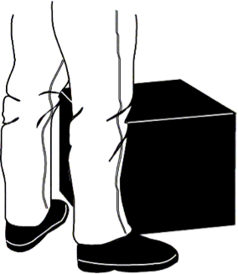 | 1. Stand close to the load with your feet spread shoulder width apart. One foot should be slightly in front of the other for balance.
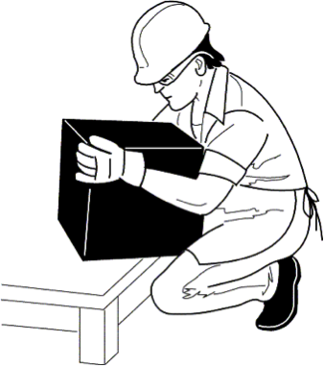 | 2. Squat down, bending at the knees (not your waist). Tuck your chin while keeping your back as vertical as possible.
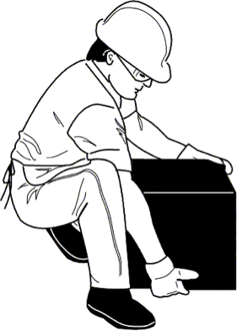 | 3. Get a firm grasp of the object before beginning the lift.
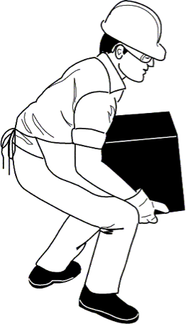 | 4. Slowly begin straightening your legs, lifting slowly. Never twist your body during this step.
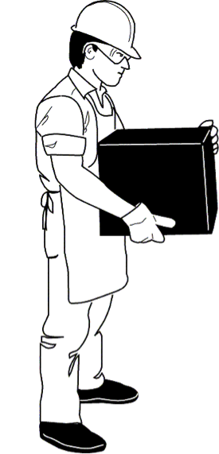 | 5. Once the lift is complete, keep the object as close to the body as possible. If the load’s center of gravity moves away from your body, there is a dramatic increase in stress to the lumbar region of the back.
If you must turn while carrying the load, turn using your feet, not your torso. To place the object below the level of your waist, follow the same procedures in reverse order. Remember to keep your back as vertical as possible, and bend at the knees.
To evaluate a worker’s lifting habits, consider the following variables: frequency of lifting, duration of such activities and type of lifting, as well as the worker’s state of health, body size, age and general physical fitness. To help in the evaluation process, consider using the Applications Manual for the Revised NIOSH Lifting Equation, which gives an equation that you can use to factor all of these variables.

Conclusion
Using proper lifting techniques can help prevent downtime due to avoidable back injuries. With a little practice, precautionary methods such as these can become good daily habits that could help prevent back injuries both on and off the job. Remember, no approach will completely eliminate back injuries. However, a substantial portion can be prevented by incorporating effective administrative and engineering controls.
Although OSHA does not have a specific standard which sets limits on how much a person may lift or carry, exposure to hazards related to heavy lifting and back injuries may be addressed under Section 5(a)(1) of the Occupational Safety and Health (OSH) Act, commonly referred to as the General Duty Clause. It states “Each employer — shall furnish to each of his employees employment and a place of employment which are free from recognized hazards that are causing or are likely to cause death or serious physical harm to his employees . . ."

Commonly Asked Questions
When carrying a load, is it okay to turn or twist my body as long as I turn with my torso?

No. You should try to minimize any turning or twisting, but if you must turn while carrying the load, turn using your feet.
Are there any guidelines I can follow to help assess multi-task lifting jobs?

Yes. To help in the evaluation process, refer to the Applications Manual for the Revised NIOSH Lifting Equation.
Will wearing a back support belt increase my maximum lifting potential?

No. Manufacturers of back support belts do not claim they increase maximum lifting potential.

