What is Forklift Safety?
Forklift safety is the set of procedures utilized for the proper use of forklifts including before and after forklift operations. These forklift safety procedures will minimize the risk of incidents and ensure that the operator and the people within the vicinity are protected.

Forklift Operator Requirements
There are numerous procedures that are in compliance with industry standards such as OSHA’s to ensure forklift safety in the workplace. The most basic operational procedure that was set by OSHA, 1910.178(q)(7), states that industrial trucks such as forklifts should be inspected every day before they’re placed in the service area. Forklifts used round-the-clock should be examined every shift. Defects or signs of wear and tear should be reported immediately. These forklift inspections can be conveniently recorded by using a digital checklist such as these forklift checklists.
Forklift operators are required to participate in and complete training before they’re allowed to operate the forklift. While OSHA doesn’t provide forklift certifications, forklift operators can get training from outside their company and get a certificate for completion of training.
Employers are responsible for certifying that the training provided was adequate and in compliance with OSHA guidelines. The required training content can be found in 1910.178(l)(3). This provision is intended for initial forklift operator training, it also stated to only include topics that are applicable to your work area.
OSHA-powered industrial truck standards recommend that employers give refresher training courses, 1910.178(l)(4), in the following events:
- The forklift operator was using the machine in an unsafe manner
- The forklift operator had been involved in an incident or near-miss accident
- The forklift operator was evaluated to be unsafely operating the equipment
- The forklift operator will be using a different type of forklift or truck
Additionally, OSHA standard 1910.178(l)(4)(iii) states that the employer is required to evaluate the forklift operator every 3 years.

Why Is It Important?
Operating a forklift is not an easy task as driving a regular vehicle. Forklift-related accidents account for 79 fatalities and 8,140 nonfatal work-related injuries in the year 2019 according to the National Security Council. These numbers are less than what it was two decades ago when CDC reported that there were 100 fatalities while 20,000 accounts for nonfatal injuries.
In the years that followed, newer technology emerged and the implementation of safety standards has been better. Statistics show that the number of forklift-related injuries are slowly decreasing every year. There is a potential to reach zero work-related forklift injuries if only employers complied with the safety regulations and forklift operators received proper training and support.

Hazards and How to Keep Employees Safe
OSHA estimates that around 20-25% of forklift related injuries are caused by inadequate training while CDC listed the top 4 types of forklift incidents which are forklift overturns (22%), worker on foot struck by forklift (20%), victim crushed by forklift (16%), fall from forklift (9%). For fatal accidents, 42% is caused by forklifts tipping over (OSHA).
The following table is the complete data for forklift operations fatalities as provided by OSHA:
Type of Accident | Percentage
Crushed by tipping vehicle | 42%
Crushed between vehicle and a surface | 25%
Crushed between two vehicles | 11%
Struck or run over by vehicle | 10%
Struck by falling material | 8%
Fall from platform on forks | 4%
Accidental activation of controls | 2%
Forklift accidents can cause the company to incur additional operating costs due to the damage on products and property. Additionally, in the event of personnel-related injuries, employers can be responsible for covering hospital, recovery, and other work-related injury expenses.
The best way to prevent forklift incidents is to be aware of the safety hazards and factors present in the work area.

Common factors of Forklift Accidents
Here are the common reasons why forklift accidents may occur in the workplace and the corresponding forklift safety tips:

- Speeding – set a speeding limit while operating a forklift. A supervisor should consistently remind forklift operators to stay on or below the speed limit. A forklift operator has the possibility of preventing major incidents such as running over someone if they maintain the proper speed.
- Moving while the load is elevated – the fork should stay on rest to safely move between destinations while carrying a load. This will allow the operator to have better visibility and control.
- Unaware pedestrians – Remind all employees to stay away from the path for forklifts and to be vigilant of their surroundings. Pedestrians are also in charge of their own safety and shouldn’t rely on vehicle operators when it’s safer and easier for a person to move away. Both Forklift operators and pedestrians can help each other stay safe and create a culture of safety in the workplace.
- Loads that exceed the weight limit – This cannot only cause damage to the forklift but also cause major accidents such as forklift overturns. Predetermine the weight limit per forklift model and have a supervisor double-check the current load.
- Other improper driving methods – Properly trained forklift operators should be knowledgeable on how to turn, back up, and use the brakes. Correct forklift driving techniques should be part of the required refresher training.

Overlooked Aspects of Forklift Accidents
Here are some aspects that are easily overlooked by people in the facility:

- Jumping out of the forklift – There is a high chance of fatality whenever a forklift operator attempts to jump out of the forklift in accidents such as forklift tipping over. To avoid getting crushed by a forklift, supervisors should remind operators to brace themselves and stay in the forklift in case a forklift is tipping over.
- Signage and markers – Similar to road signs, the facility or area a forklift covers should have visible signs on the floor, aisle, and all around. These signs are usually painted on and display the flow of traffic. Some other signs are “stop and look at hazards” for junctions, and labels such as “loading area.”
- Crowded pathway – Facilities should have enough space for a forklift to maneuver on. This space should be big enough for a forklift operator to back out off and change directions. Pedestrians should avoid crossing crowded pathways and take another route.
- Inspection and maintenance of forklifts – As time goes on, wear and tear due to the frequency of using the forklift can occur. Daily inspections are required to help keep forklift operations safe and in compliance with regulations. Supervisors are responsible for ensuring that inspections are conducted by the operator before and after their shifts.

Additionally, here are some basic forklift safety tips and protocols:
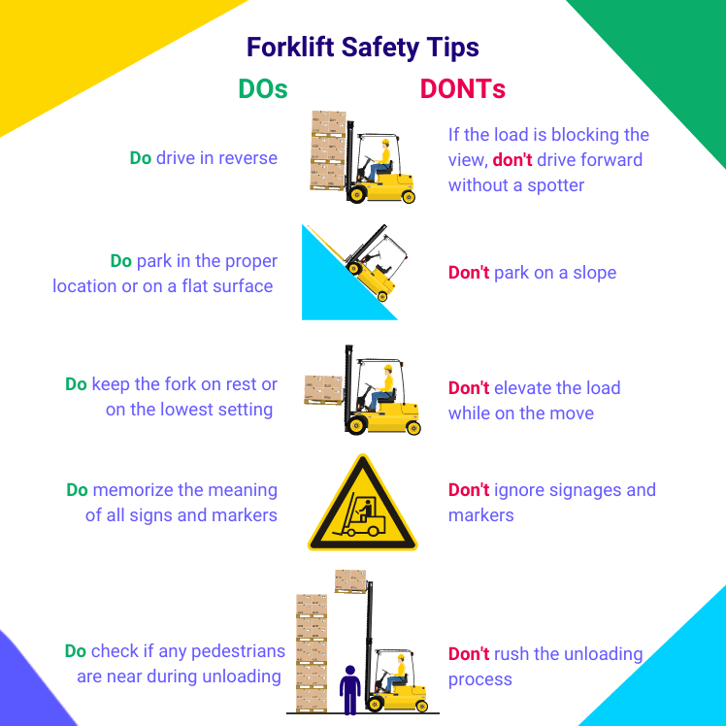
Forklift Safety Tips: Dos and Donts | SafetyCulture

OSHA Forklift Requirements
Below are Frequently Asked Questions (FAQs) about the forklift requirements of the Occupational Safety and Health Administration (OSHA) and their corresponding answers:

Does OSHA require forklift inspections?
Yes, OSHA requires forklift inspections. All industrial trucks need to be examined before use, and forklifts should not be used when the inspection reveals any condition adversely affecting the safety of the vehicle.

Does OSHA require daily forklift inspection?
Yes, OSHA requires daily forklift inspection. Operators should perform forklift pre-use checks at least once a day, but when industrial trucks are used round-the-clock, they should be inspected after each shift.

Does OSHA require a forklift checklist?
No, OSHA does not require a forklift checklist, though it provides sample forklift checklists for various types of industrial trucks and, as mentioned previously, requires daily forklift inspections. According to OSHA, operators should modify forklift checklists based on the owner’s manual, specifications, manufacturer’s recommendations, and other workplace needs.
Aside from conducting forklift inspections (which can be facilitated by the use of checklists), OSHA also requires all forklift defects to be reported immediately and those qualified mechanics correct them.

4 Essential Forklift Tips for Operators
Failure to inspect powered industrial trucks before use is one of the most cited OSHA violations in terms of forklift safety. Here are some guidelines to help forklift operators conduct forklift inspections and perform pre-operational, safety, and maintenance checks easily.

Tip #1: Inspect from the outside-in during engine off checks

It can be easier for operators to perform the necessary pre-use inspections by practicing the outside-in technique for assessing the safety of a forklift.
What should I check before operating a forklift?
- Check the condition of tires, forks, and load backrest extensions.
- Check the safety decals and nameplates and ensure that they are clear and visible, especially for load capacity details.
- Check the fluid levels, including but not limited to oil, water, and hydraulic fluid.
- Ensure that the operator manual is onboard before mounting the lift truck.
- Wear the appropriate Personal Protective Equipment (PPE).
- Practice proper ergonomic procedures to avoid slipping or tripping upon entry.

Tip #2: Investigate unusual noises during engine checks
Forklift operators should immediately report unusual noises or vibrations during operational inspections. They should also do the following:
- Check if the seat belt works and wear it at all times.
- Look out for leaks in the operator compartment, especially while the engine is running.
- Test the brakes, controls, and steering operation to ensure that they are functioning properly.
- Test the forklift’s horn, lights, and alarms.
- Keep an eye out on the hour meter and battery discharge indicators when operating an electric industrial truck.

Tip #3: Be mindful of potential hazards for removal from service
While driving, be alert for potential fire, leakage, overheating, and mechanical breakdown. If any of these defects among other safety issues are detected, forklift operators should stop, park the vehicle, and get help. While meeting deadlines and getting the job done matters, your safety and the safety of those around you matter more.

Tip #4: Schedule preventive maintenance inspections regularly
Regular maintenance is crucial to keep the safe operation of forklifts. A sign that could mean lift trucks are overdue for their adequate maintenance is when they skid or slide while in operation because of grease and spills. During preventive maintenance, check if powered industrial trucks are free of debris and lint to avoid improperly working controls.

What Should be Included in a Forklift Safety Checklist?
The contents of a forklift safety checklist should, at the minimum, include all essential parts of the forklift being checked and consider the type of inspection to be done involving the forklift. The most basic forklift checklist is divided into two sections: pre-start or pre-operational and after starting the engine.

Pre-start or Pre-operational
During pre-start, the following, among other things, are checked:
- Tires and rims
- Engine oil, hydraulic oil, battery fluid, coolant level, and hydraulic levels
- Possible leaks
- Visible damage
- Locking mechanism
- Rams
- Battery
- Engine bay
- Load plate
- Overhead and backrest guards
- Operator’s seat
- Controls
- Seat belt

After Starting the Engine
The following are checked after starting the engine to make sure they will function during operations:
- Controls, pedals, and indicators
- Revers buzzer and beacon
- Lights and flashing strobe
- Steering wheel
- Park brake and foot brake

